Assignment No. 9
Title: Custom Application (Mini Project) using Sales force Cloud.
Problem Statement: Design and develop custom Application (Mini Project) using Sales force Cloud.
Objective: To develop custom application (Mini Project) using salesforce cloud
Outcome: Application in SalesForce.com using Apex programming Language.
Procedure:
Step 1: Signup or login
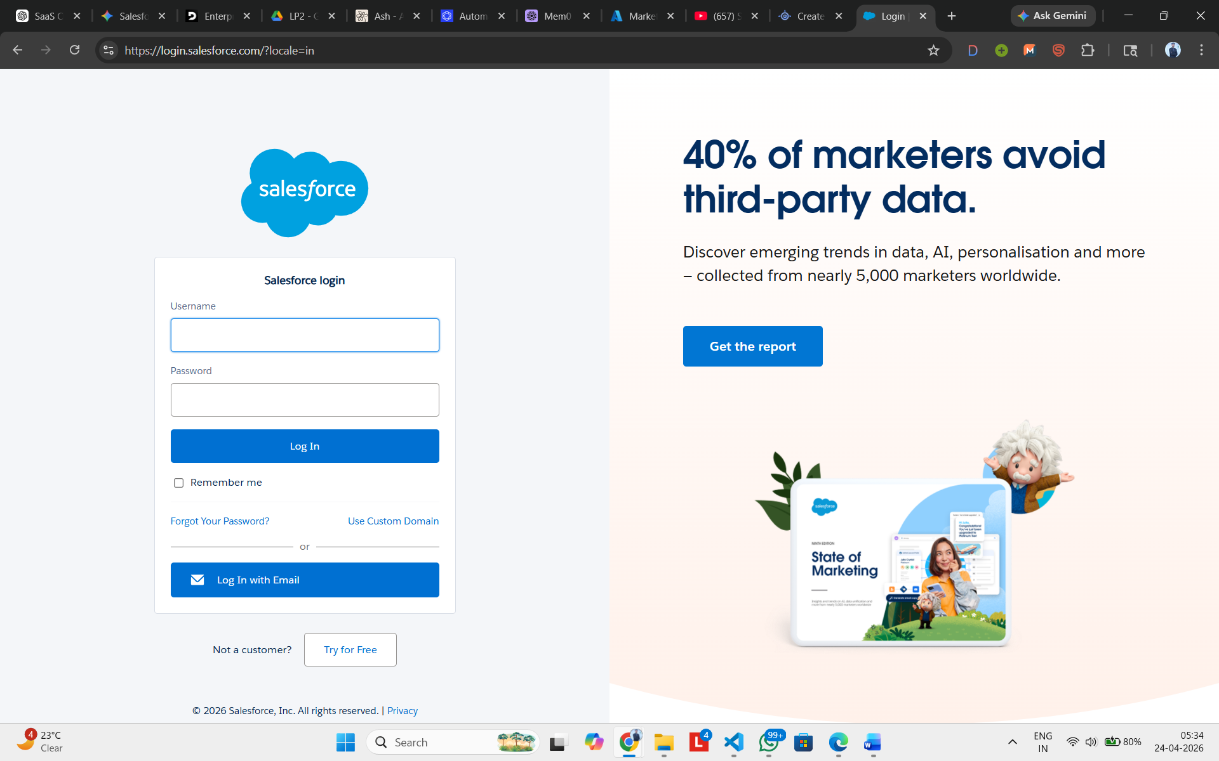

Step 2: After this you will reach the Dashboard
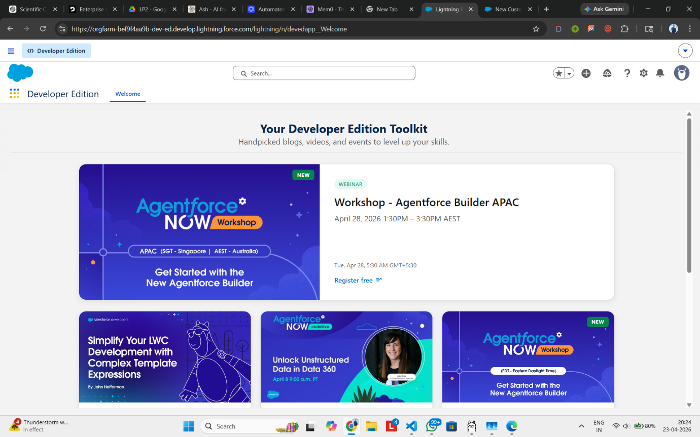
Step 3: Create custom object for Task Manager
Go to: Setup → Object Manager → Create → Custom Object
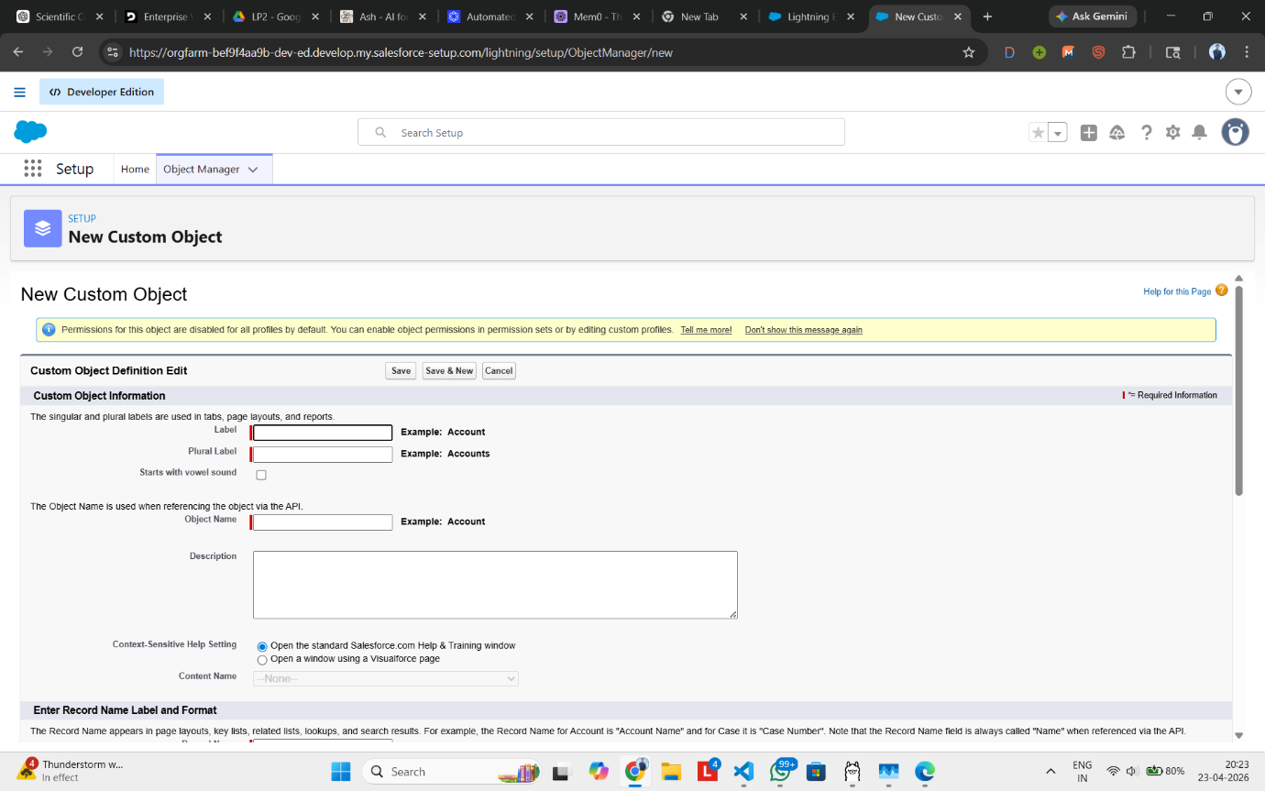
Step 4: Create the fields Description, Priority, Status and Due Date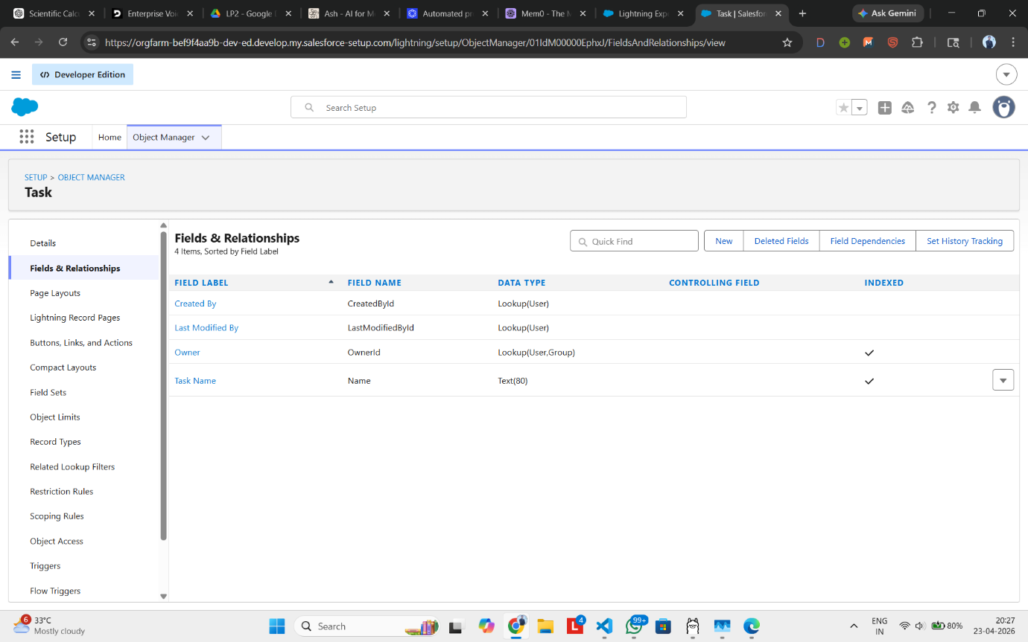

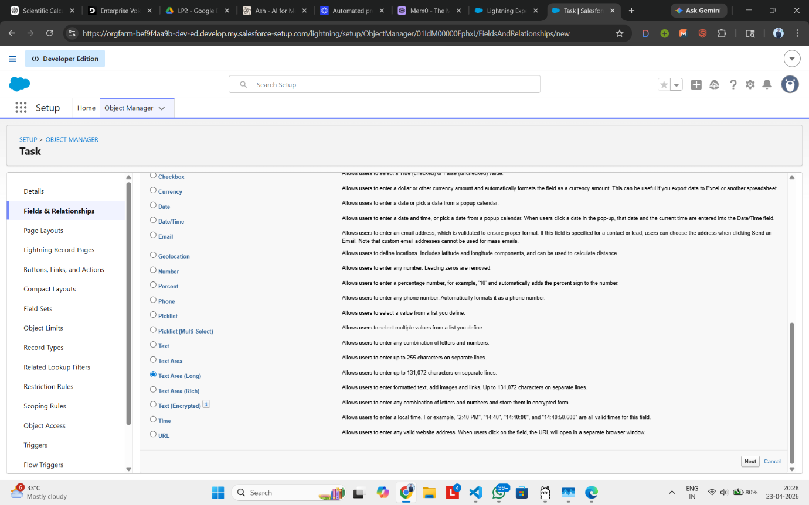
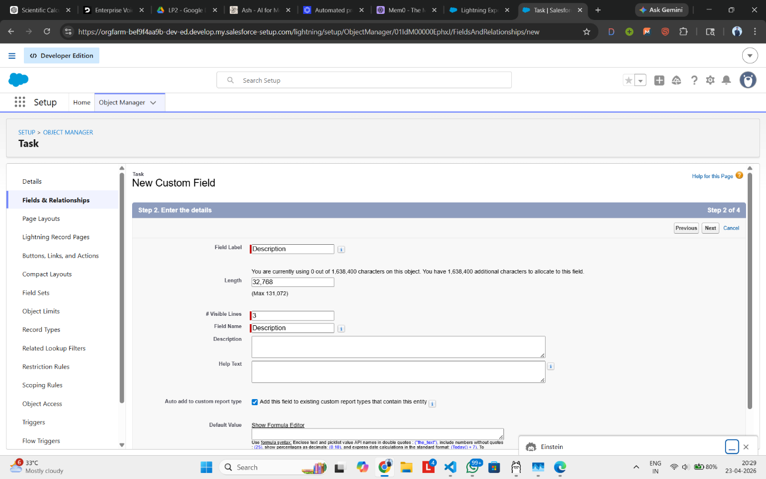
Step 5: Add Validation Rule
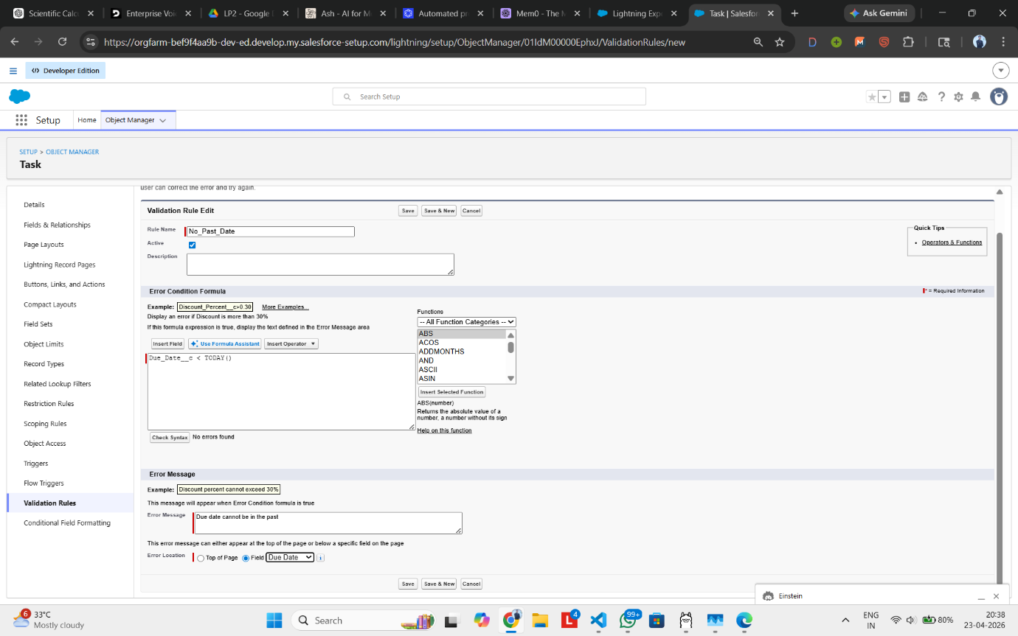

Step 6: Create Apex Trigger
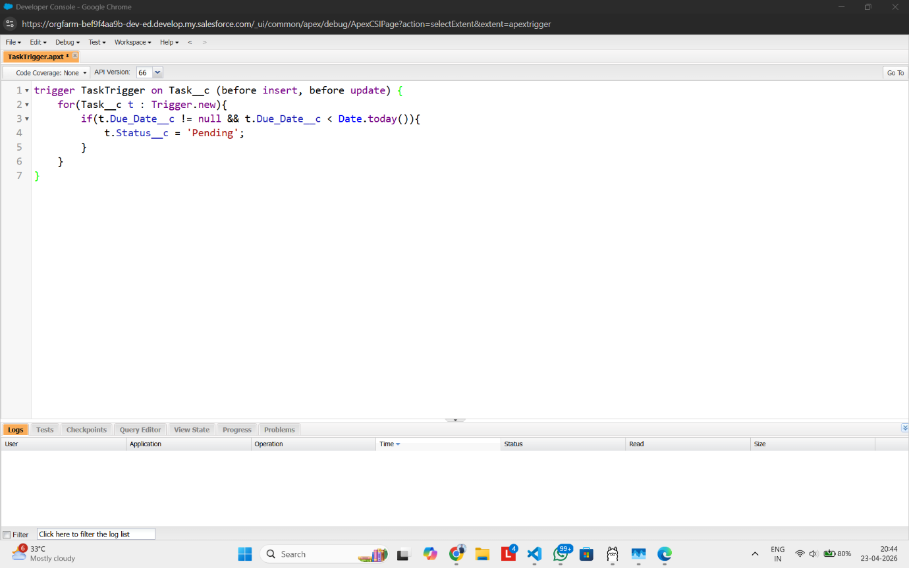
Step 7: Create App ‘Task Manager’
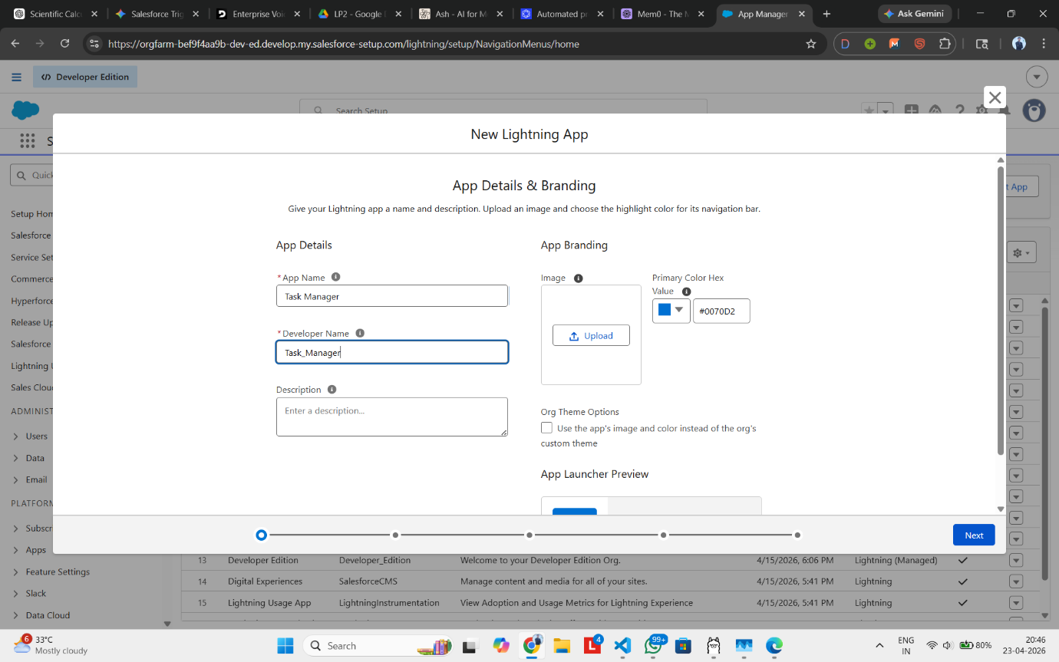

Step 8: Add Tab ‘Task’
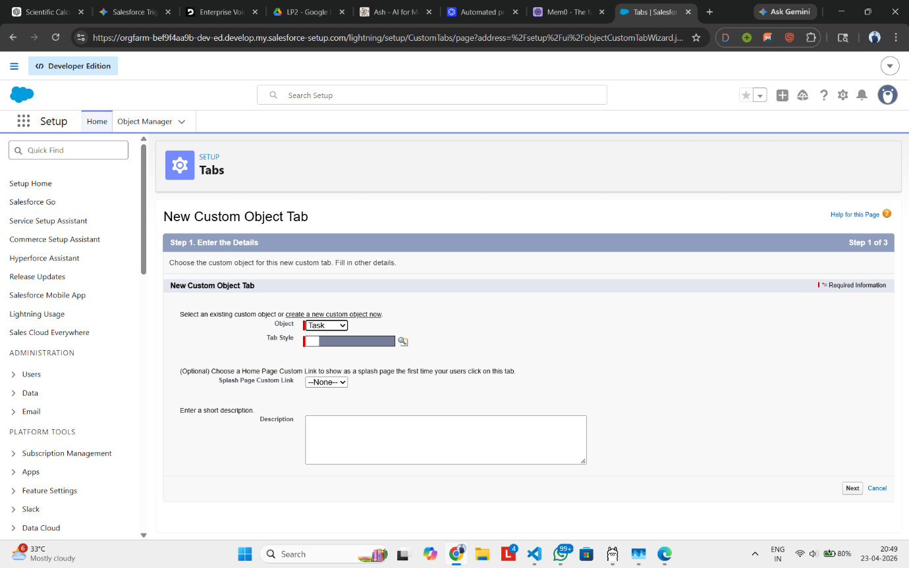
Step 9: Create Apex Controller class
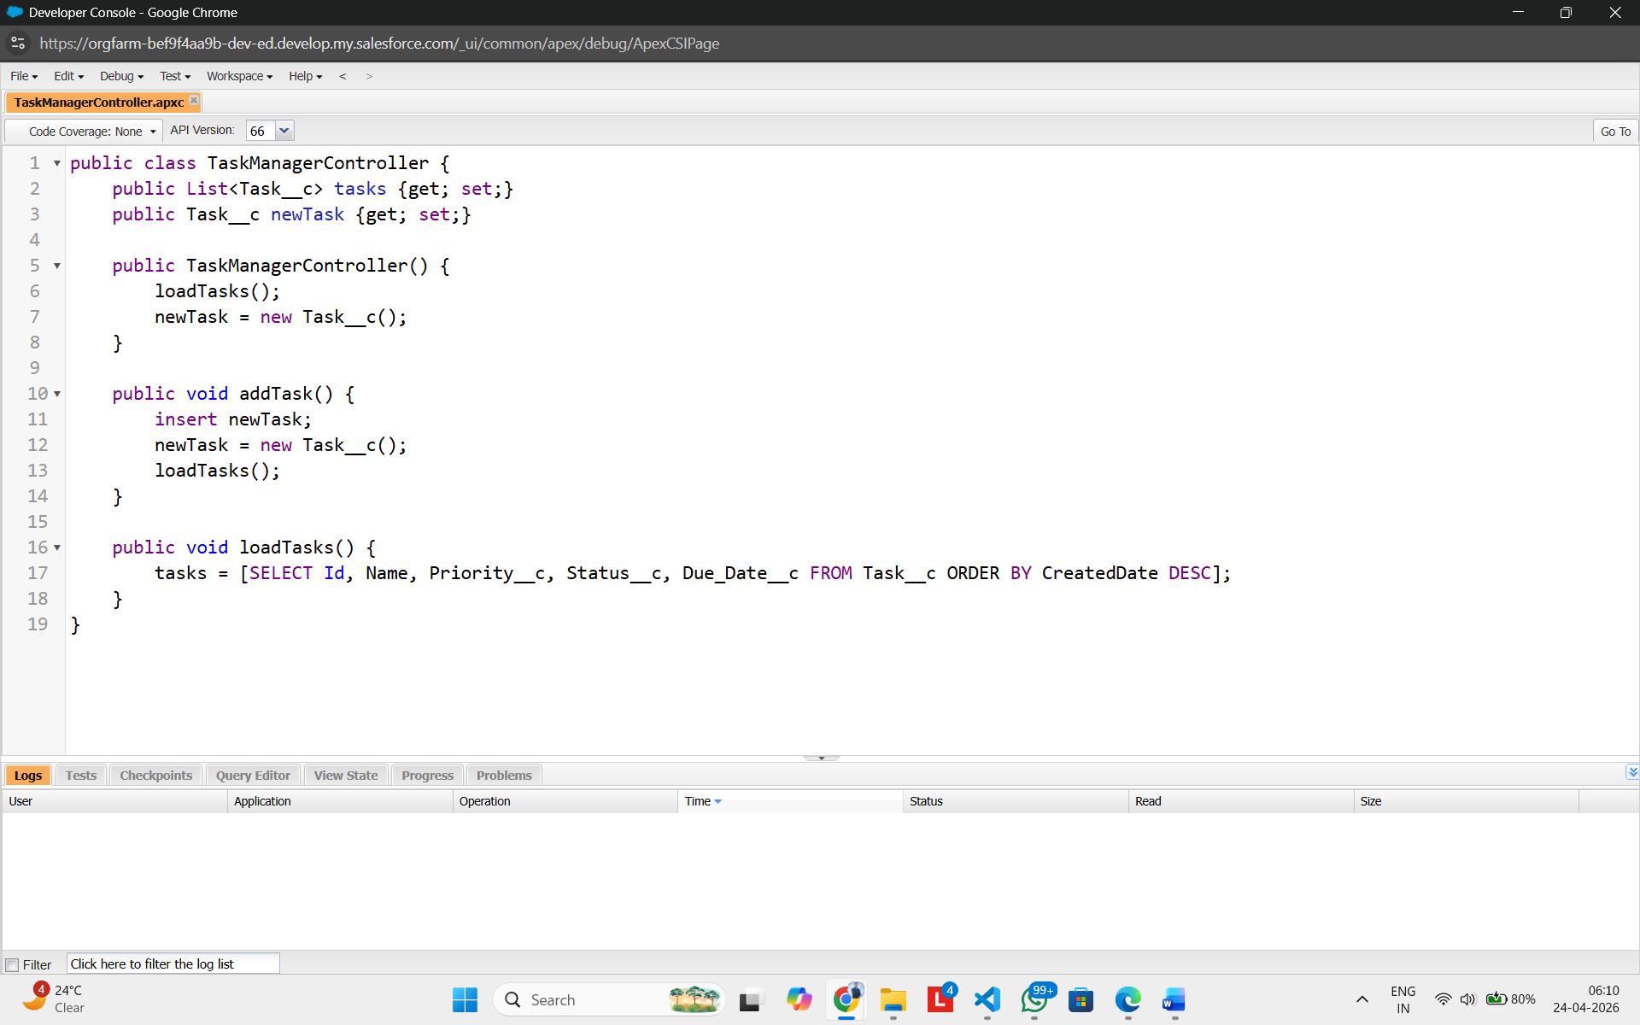

Step 10: Create VisualForce Page
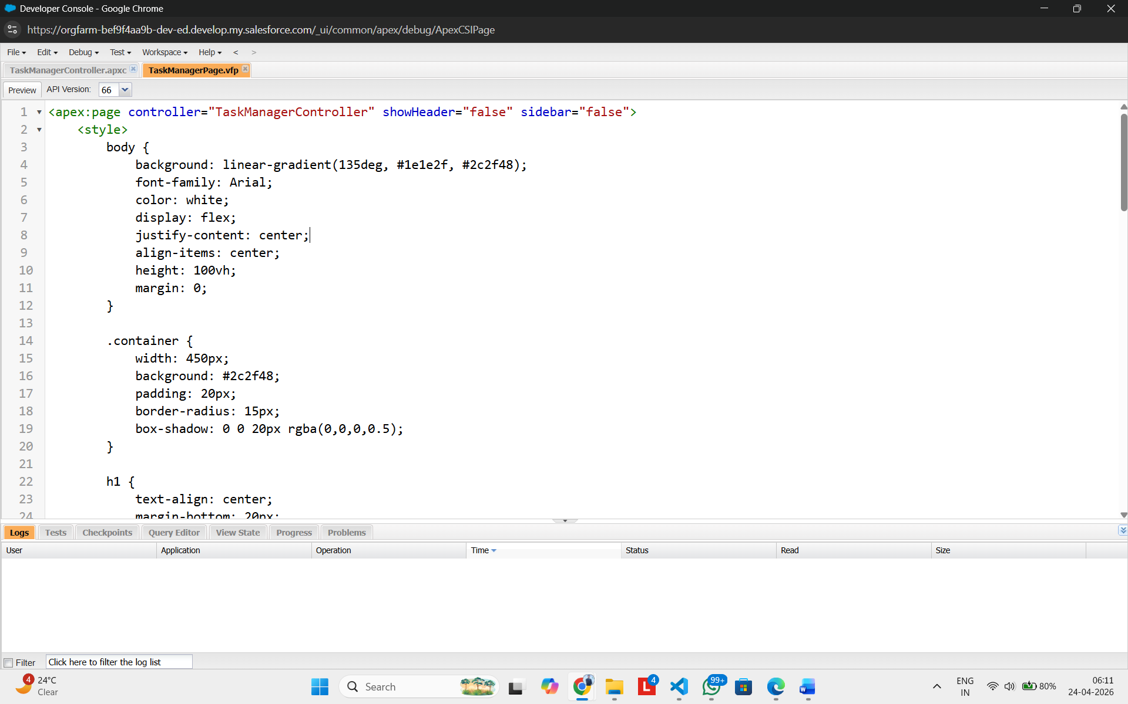
Step 11: Preview App
